This is a test to see that the document is rendered correctly

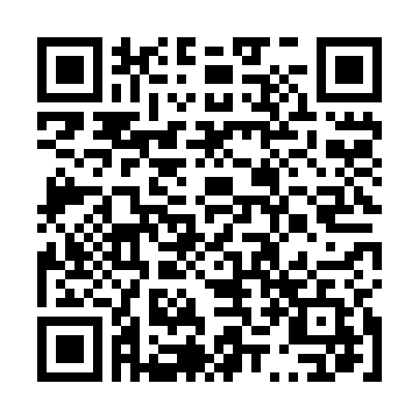
Testing the Arial Font
Testing the Times New Roman
This is the end of the Doc

