Original | SafeView
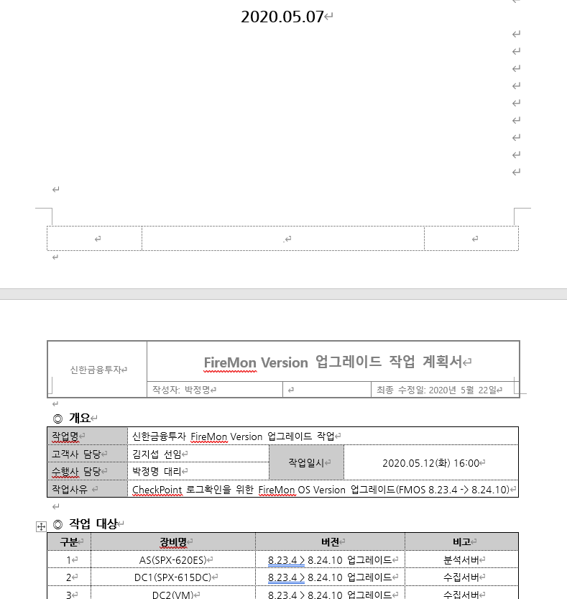 | 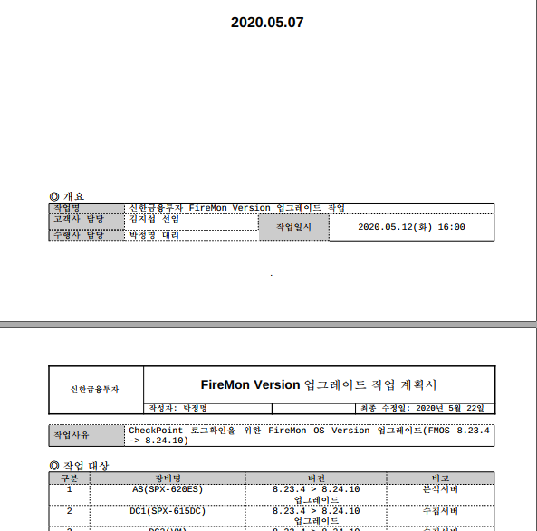
Original file name : 작업계획서_FireMon_신한금융투자_20200507_v001.doc
Tested link : https://safe.menlosecurity.com/docview/viewer/docN359080497F3C7f4855f5d
3709690d0bdd020774ab5038d684adccefba18e9bca33d97bf70a21
The template is corrupted in the document.

Original | SafeView
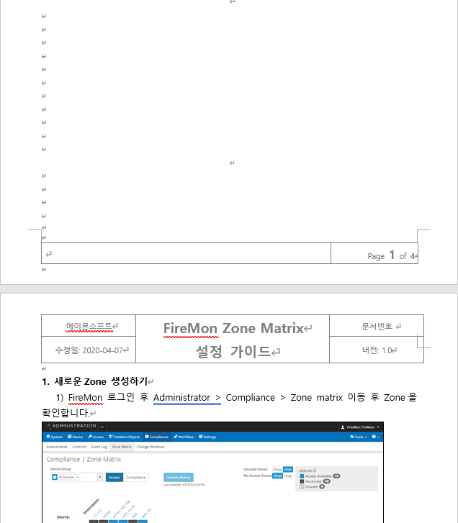 | 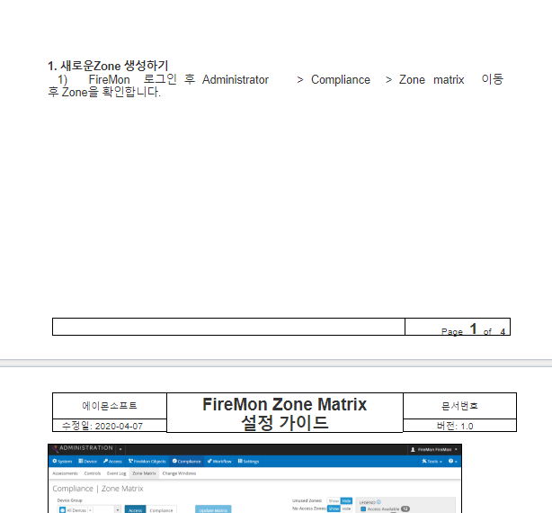
Original file name : FireMon_Zone Matrix 설정 가이드_v0.1.doc
Tested link : https://safe.menlosecurity.com/docview/viewer/docN4F9EF6D8961A4e290dd088f
743743600798d4984c22fcd246430a2e9d3ae73a8625c003c02e6
The template is corrupted in the document.

Original | SafeView
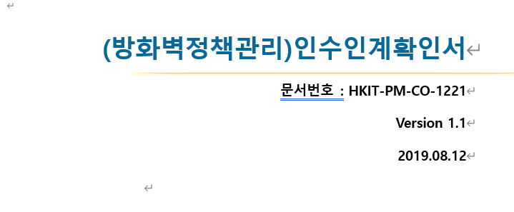 | 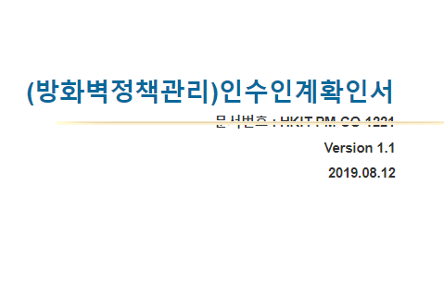
Original file name : HKIT-PM-CO-1221_인수인계확인서(방화벽정책관리)_v1.4_20190808.docx
Tested link : https://safe.menlosecurity.com/docview/viewer/docN4F9EF6D8961A9e084d81f1
c0e83dab9ef52f0bd0825515849bf6286ccc69958e14dc0b7d79e9
The character position in the document is incorrect.

Original | SafeView(Web 미리보기)
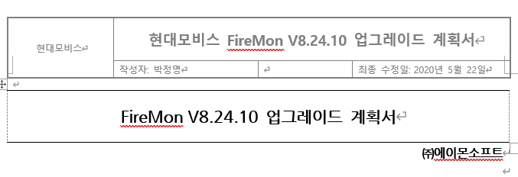 | 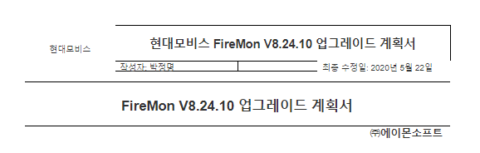
Original file name : 업그레이드작업계획서_FireMon_현대모비스_20191217.doc
Tested link : https://safe.menlosecurity.com/docview/viewer/docN4F9EF6D8961Ab049d54471
0a4c9fa9c4f0bbf4dce6d614b8827ba174bb3d523d8440c0eee234
The template is corrupted in the document.

Original | SafeView
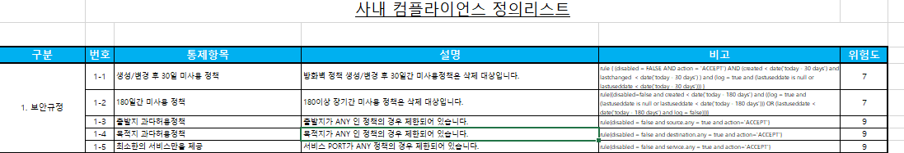 | 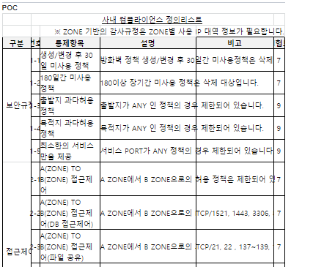
Original file name : FireMon_컴플라이언스_샘플_v1.1.xlsx
Tested link : https://safe.menlosecurity.com/docview/viewer/docN4F9EF6D8961Ac6b256b32
8f7bc9e2eca192626df0159b0cfb73f779455d22448d5344cfd3b51
The template is corrupted in the document.

Original | SafeView
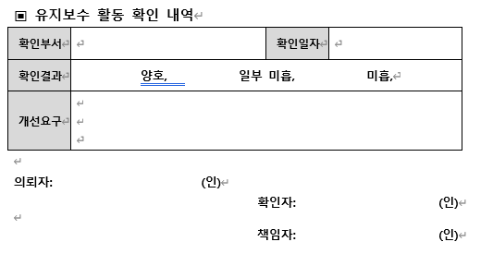 | 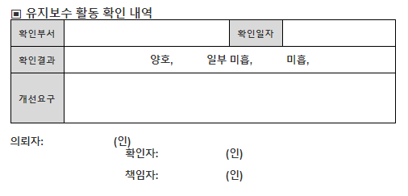
Original file name: 201901_유지보수확인서_방화벽정책관리솔루션_퀀텀양식.doc
Tested link : https://safe.menlosecurity.com/docview/viewer/docN4F9EF6D8961A01ade33b4
1ebeb8acc13575058c7c3f3fd46834906224849d91d06c00f1929ed
The character position in the document is incorrect.

