South and West of England
U15 Cricket Team

West Indies Tour 2010
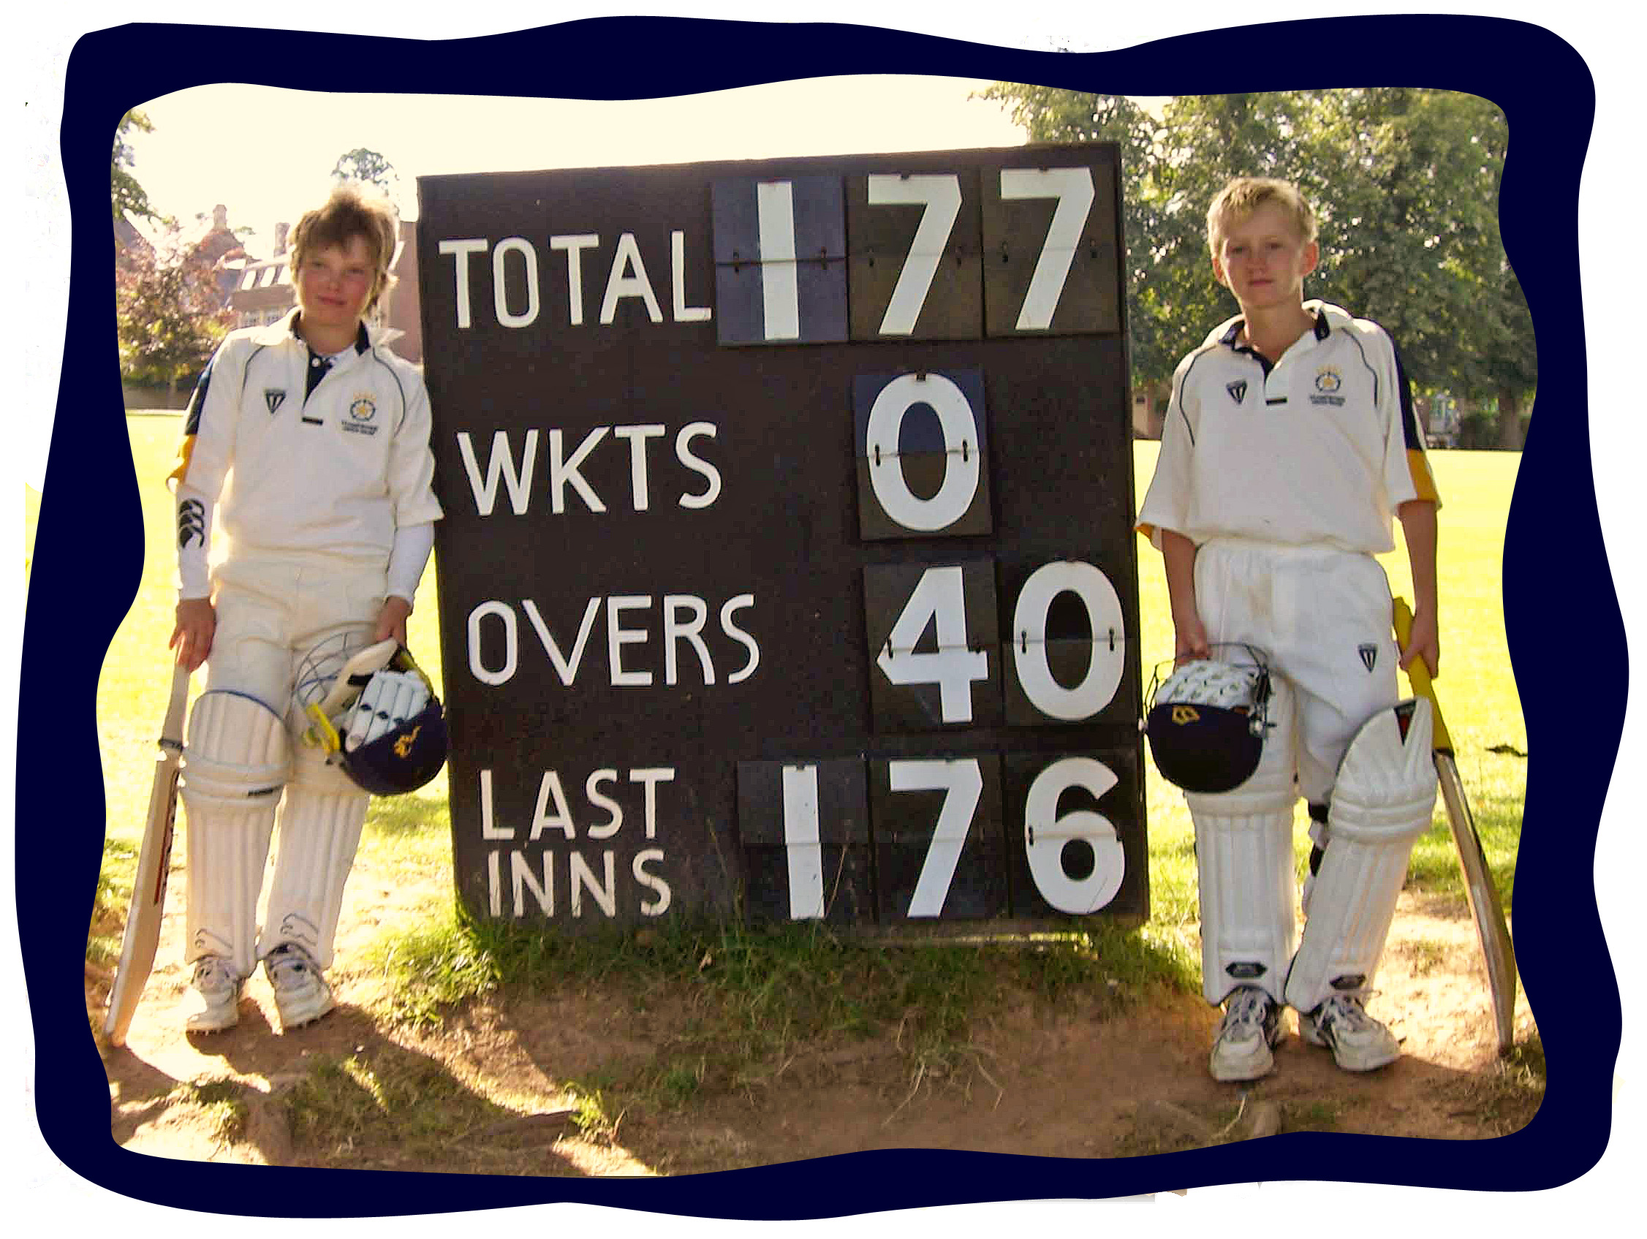
a memorable partnership

James Halson and Jack Wood playing for Hampshire against Lancashire 2 days before they were invited to trials for the South and West of England Team in 2007.

Two years later James and Jack have been selected to represent the South and West of England U15 team for their tour of the West Indies in April 2010.

The team comprises 16 boys from 10 counties in the South and West.

James and Jack have played cricket together since they were 8 years of age, first at school and club, then at County and now representing the South and West of England

Hampshire County Cricket

James and Jack have worked hard at their cricket and this hard work was rewarded in 2007 when they were both asked to join the Emerging Player Program at Hampshire, this is an ECB initiative which enables each county to give intensive training to 8 players aged between 13 and 16. James and Jack are just starting their 3rd year in this program. The program involves travelling to the Rose Bowl twice a week, once for an individual specialist coaching session and once for a group session.

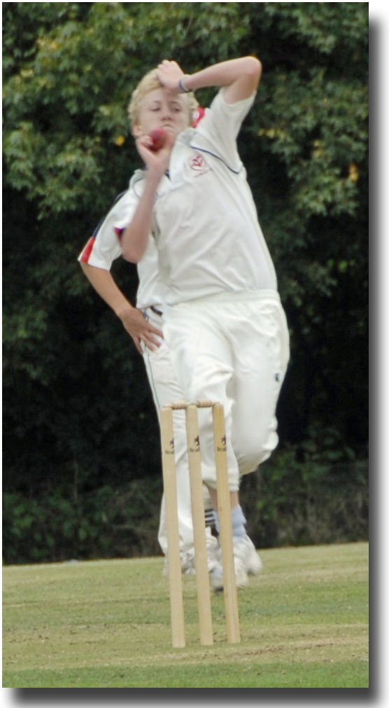
They have enjoyed success playing for the Hampshire youth teams from U10 through to U16, for the last 2 years playing in teams above their age group. They have been selected to go to South Africa with the Hampshire U16 Development Squad in February 2010.

Jack bowls with a very
effective swing action
which deceives
batsman

He contributes with
the bat coming
in at 3 or 4
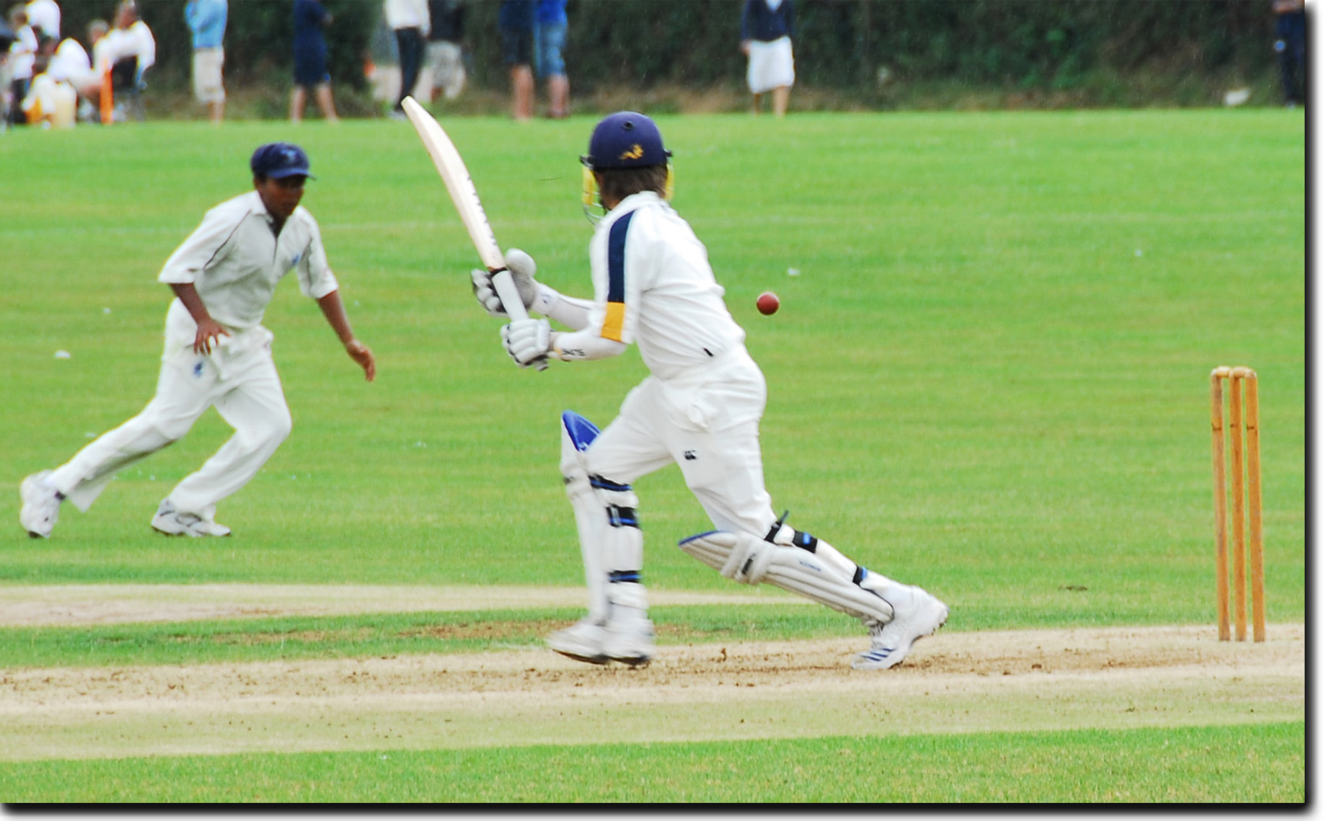

James opens the batting and bowls leg spin

South and West of England Cricket

Last year James and Jack were selected to play for the South and West of England in a Regional tournament, unfortunately, the weather was terrible and matches against The North and The Midlands were rained off, only one match was played against London and East England. James, who opens the batting, put on a top score of 62 before being caught and Jack took a wicket at a crucial time in the match leading to a win for the South and West team.

Their target for this year is to play well in the West Indies and earn a place in the team for the Bunbury Festival next summer, where the U15 England Squad will be selected.

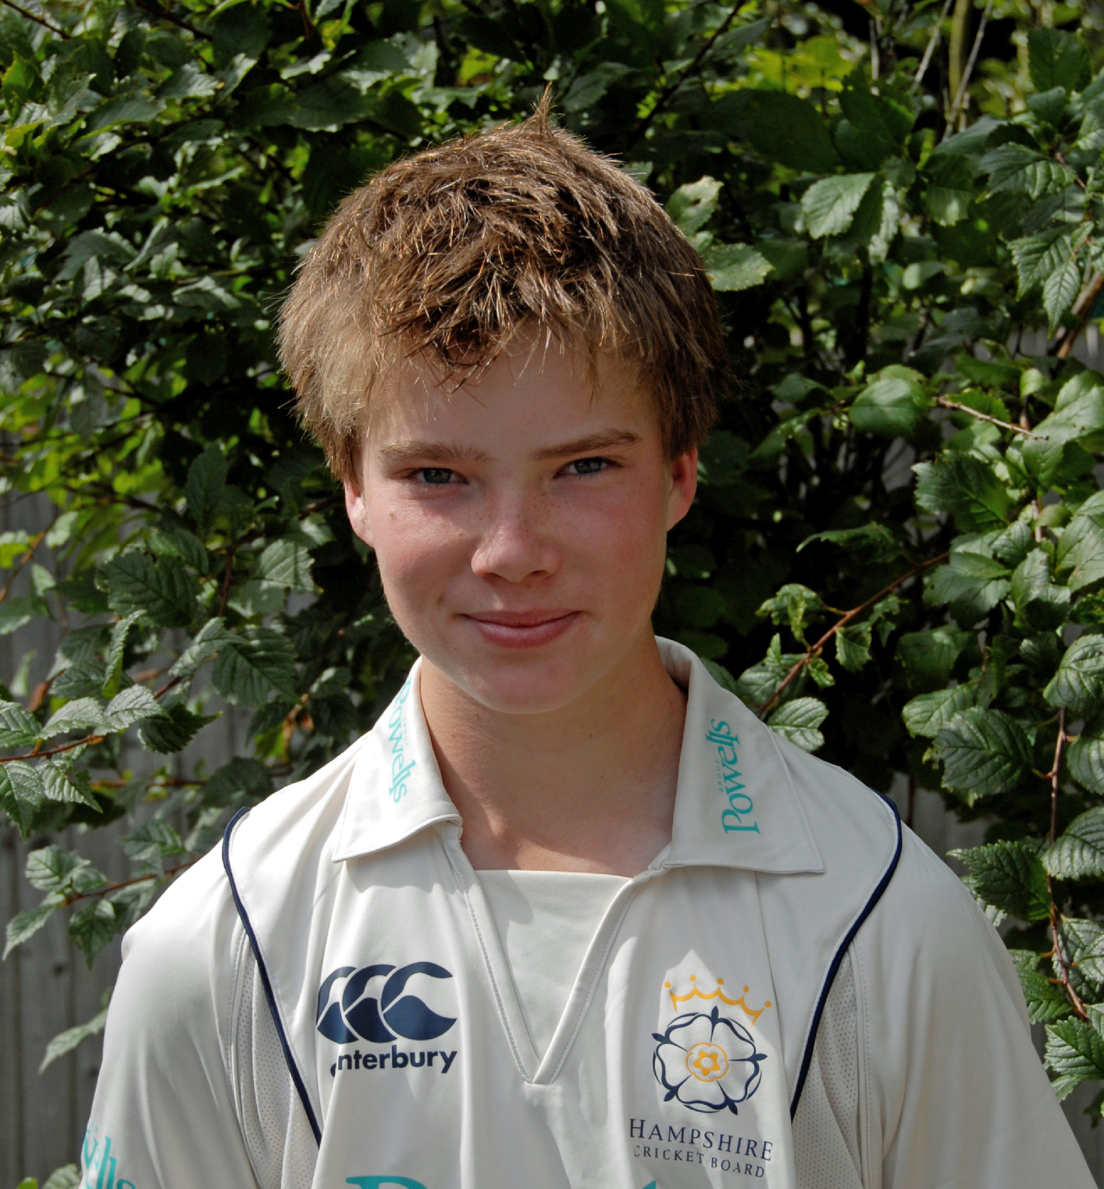
James Halson

D.O.B: 12.11.94

Role: RHB
LS

Club: Yateley CC

Representative South & West of England U14
Honours: Hampshire U15
Emerging Player Program

Personal best 108 no – Hampshire v Dorset U11,
performance to although my favorite was a partnership of
date: 177 with Jack Wood to beat Lancashire by 10
wickets when we were U12.

Cricket Heroes: Marcus Trescothick, Shane Warne

Leisure Watching and playing sport, particularly skiing
Activities: and surfing when I get the chance, hanging out
with my friends.

Favourite Food: Spaghetti Carbonara, Salmon

Favourite Film: Super Bad

Favourite music: Black-eyed Peas, but I listen to a real mixture

Aim for 2010 Play well and score as many runs as I can
Season: during the season. Enjoy the experience of
playing in South Africa and The West Indies. Play
for Hampshire U15/U16s before selection for the
U16 Jersey Festival at the end of August.
Represent the South and West of England at the
Bunbury Festival.

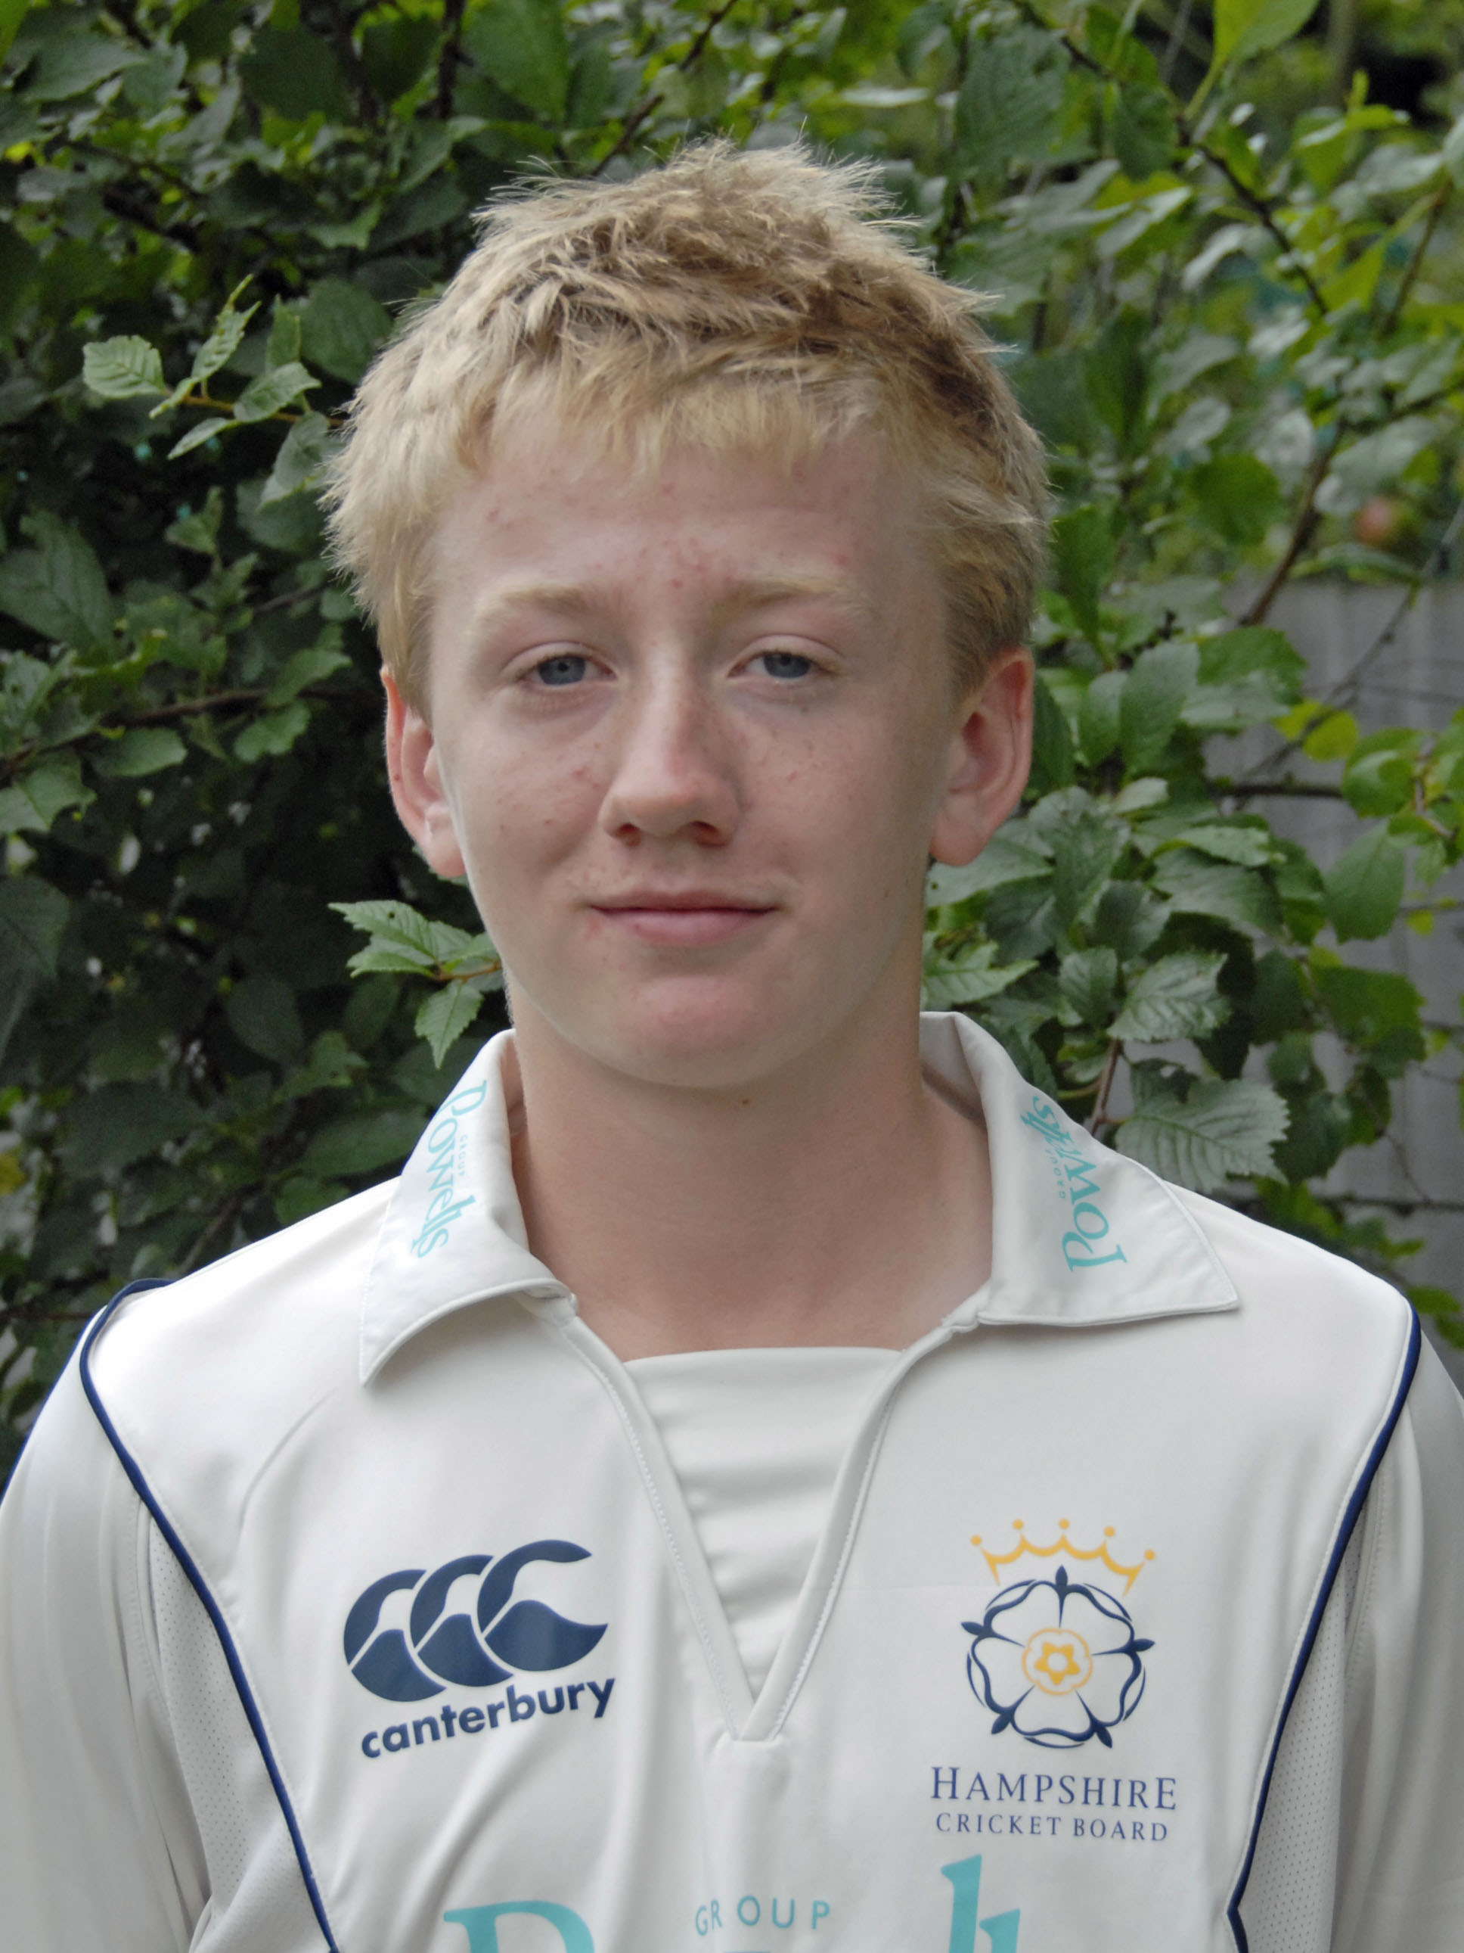
Jack Wood

D.O.B: 04.11.94

Role: RHB
RAFM

Club: Yateley CC

Representative South & West of England U14
Honours: Hampshire U15
Emerging Player Program

Personal best 6 wickets for 6 runs, Hampshire v Middlesex U11,
Performance to all clean bowled! I think this will be hard for
date: me to beat!

Cricket Heroes: Michael Clarke – Bat
Jerome Taylor – Bowl

Leisure Activities: Relaxing with mates

Favourite Music: Pretty much anything, R&B, Pop, Rock

Favourite Film: Bad Boys 2

Favourite Food: Roast dinner

Aim for 2010 South & West – have a good West Indies tour
Season: and then Bunbury Festival.
Hampshire - play for U15/16/17s and then
selection for Jersey Festival

Tour Itinerary

The team will play matches against national teams as well as regional and club island teams, often at an older age group. The schedule is demanding but gives the boys a fantastic opportunity to play cricket at the highest level in a part of the world where cricket is a way of life.

Tuesday, 30th March | Depart London Gatwick for Barbados
Wednesday, 31st March | Fly to Trinidad
Thursday, 1st April | Match v North East and North Trinidad
Friday 2nd April | Match v South East and South West Trinidad
Saturday 3rd April | Sightseeing
Sunday 4th April | Match v Trinidad and Tobago National Team
Monday 5th April | Fly to Guyana
Tuesday 6th April | Match v Essequibo
Wednesday 7th April | Match v Berbice
Thursday 8th April | Match v Guyana
Friday 9th April | Fly to Barbados
Saturday 10th April | Match v Barbados
Sunday 11th April | Sightseeing
Monday 12th April | Match v Phoenix Academy
Tuesday 13th April | Match v Barbados
Wednesday 14th April | Depart Barbados
Thursday 15th April | Arrive London Gatwick

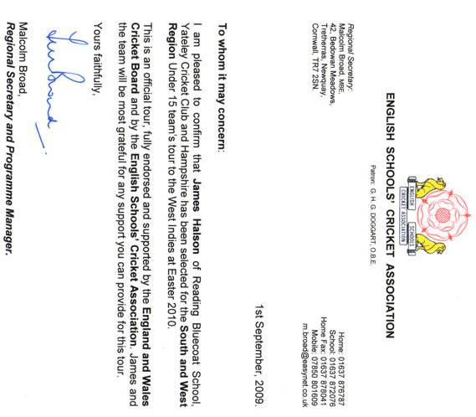
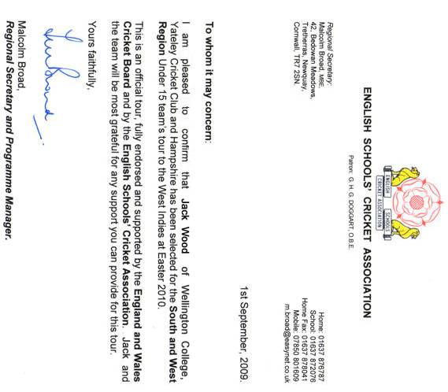

We have to fund the trip ourselves so are earning money
by babysitting and pet-sitting and are asking local companies
for support.

We would very much appreciate your support
which you can show:

by placing an advert or good luck message in our
tour brochure (from £75)

or

through a donation which will be acknowledged
at the back of the brochure.

Please see enclosed sheet

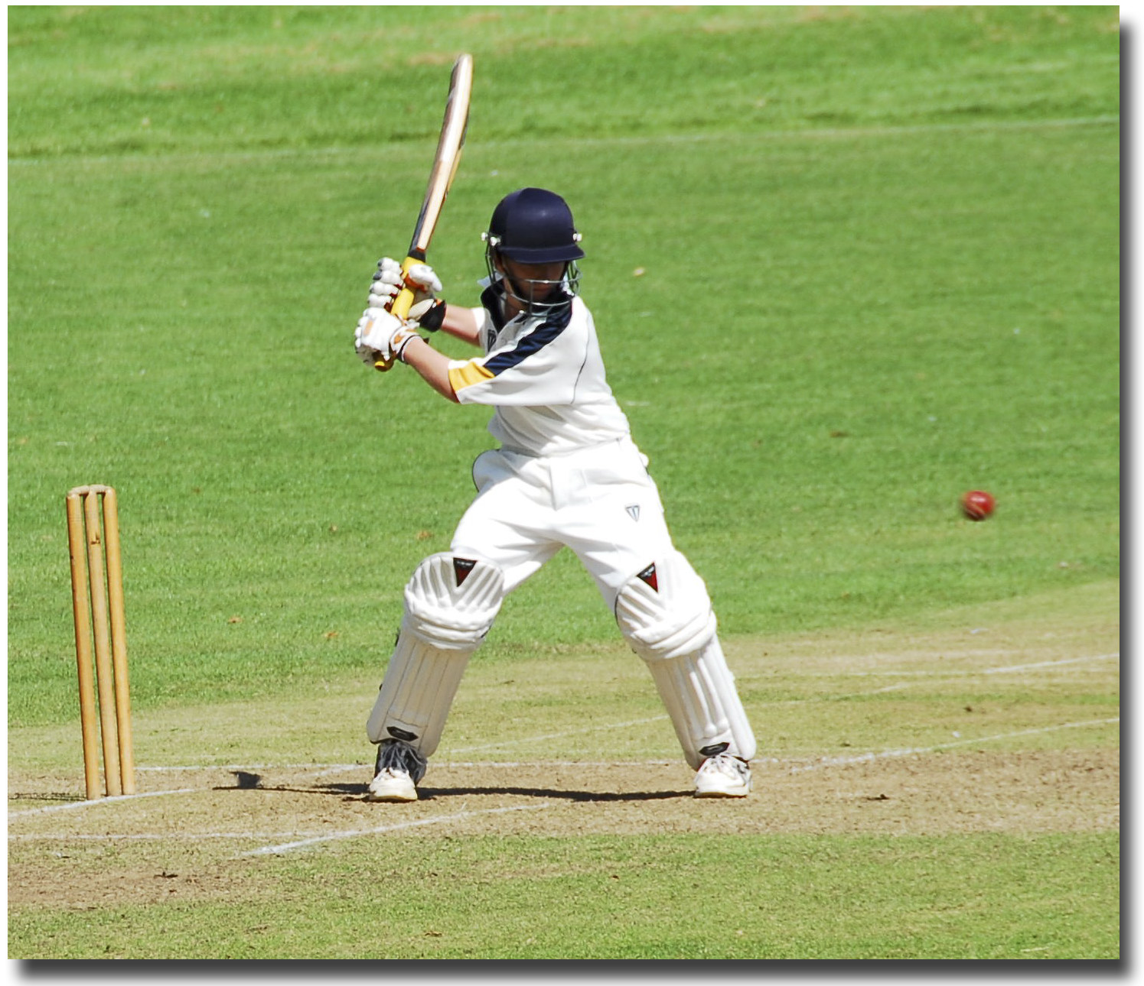

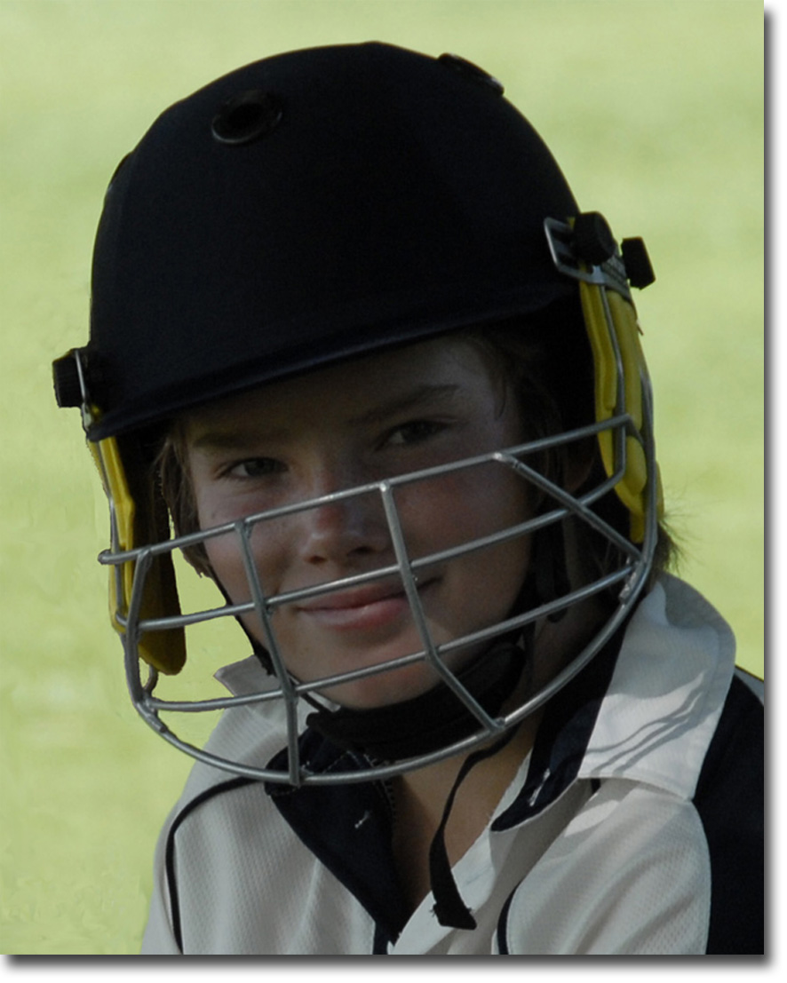

Thank you for taking time to read this leaflet

If you require any more information please contact us by email at
jjhalson@yahoo.com

