Accessible Word Documents

# Contents

## [Features of accessible documents](" \l "_Features_of_accessible)

[Documents structured using styles](#_Documents_structured_using)

[Alt text labels](#_Alt_text_labels)

[Data tables](#_Data_Tables)

[Hyperlinks](#_Hyperlinks)

## [Online resources](#_Online_Resources)

# Features of accessible documents

Because most documents are originally created in Microsoft Word, this discussion will only deal with Word documents. An accessible document has the following characteristics:

1. Its structure (headings, bullets, columns, etc.) is actually a part of the code of the document, not just a set of visual features. To create this structure, use "styles" and other toolbar options to format the document.
2. Every non-text element in the document has a text label; this is known as "alt text." Complex items like graphs or maps also have a longer description available to inform blind or low-vision readers of the relevant content.
3. Any data table has been created using the table tool.
4. Hyperlinks contain meaningful labels that will inform an individual navigating the document by means of a screen reader.
5. Long documents contain a table of contents with links to each section, as well as links at the end of each section that allow readers to return to the table of contents.
6. The document exists in a format that users will be able to open, and that will interface with a variety of assistive technologies. This means, at a minimum:

* that you provide the document in digital format so that students who use screen readers, magnifiers, text-to-speech software, refreshable Braille display, or other assistive technologies can use those when working with the document; and
* that you offer the document in forms that students are most likely to be able to open and that will preserve the accessible features you built into the original: .doc (not .docx), .rtf (Rich Text Format), or for documents with no complicated tables, PDF (created using Adobe Acrobat).

1. The document conveys information effectively:

* The language is clear;
* The layout is as simple as possible for the purposes it serves;
* Text is divided into manageable and clearly-defined sections; and
* There is plenty of white space where the eye can rest.

WebAIM addresses the first five issues listed above (and others) in a helpful article, “[Microsoft Word](http://webaim.org/techniques/word/).”

[Back to Contents](#_Contents)

## Documents structured using styles

### Why do it with styles?

To get a sense of what it would sound like to hear a screen reader read a document that uses styles and one that just uses font-size changes, bold, and tabs to create headings, look at the mock pages below. (For the full-size text of these pages, see the “[Who Benefits](#_Who_benefits_from_1)?” section below.)

Example using styles



Because the headings and bullets are embedded in the code of the first document (above), the screen reader will alert the listener to the existence of those headings and bullets. However, it will read the second example (below) – the one created without styles – as continuous text with only line breaks. The listener will find it very difficult to discern that the document gives three separate answers to the question, “Who benefits from course documents structured using styles?” S/he will not be aware that there are three headings of the same level, each with one or more bullets under it.

Example without styles

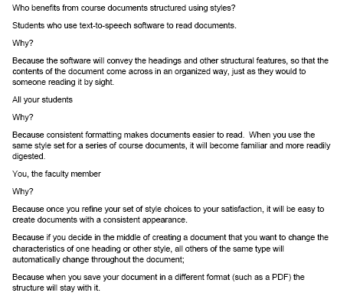

## How do I use the styles tools?

The styles tools take up almost the entire right-hand half of the Word 2007 toolbar. (See the yellow arrow on the screen shot below.)

Styles menu

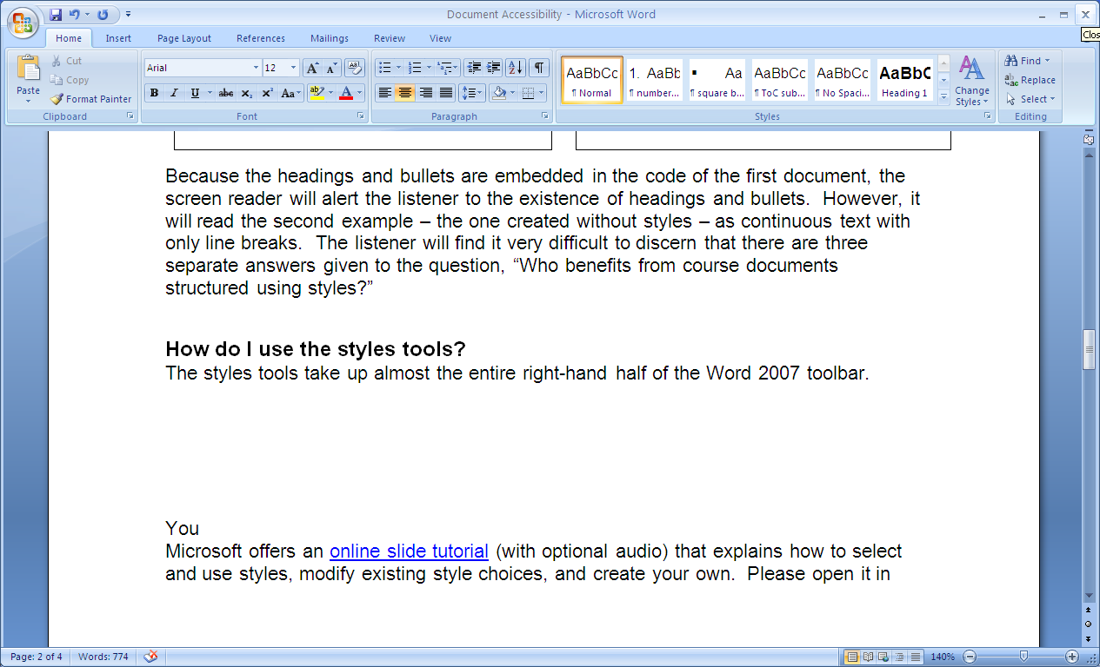

Microsoft offers an [online tutorial](http://office.microsoft.com/en-us/word-help/format-your-document-with-styles-RZ010356279.aspx) (with optional audio) that explains how to select and use styles, modify existing style choices, and create your own. Open it in Internet Explorer if you would like to download the practice exercises; other browsers will not download correctly.

Besides styles, there are other choices on the toolbar that will help you create a document with true – not just apparent – structure. If you don’t want to use a style for a bulleted or numbered list, create one by clicking on the appropriate choice in the “paragraph” menu (see the purple arrows on the screenshot above). Also, to create columns, use the column choice in the “page layout” menu instead of inserting tabs to give the appearance of columns.

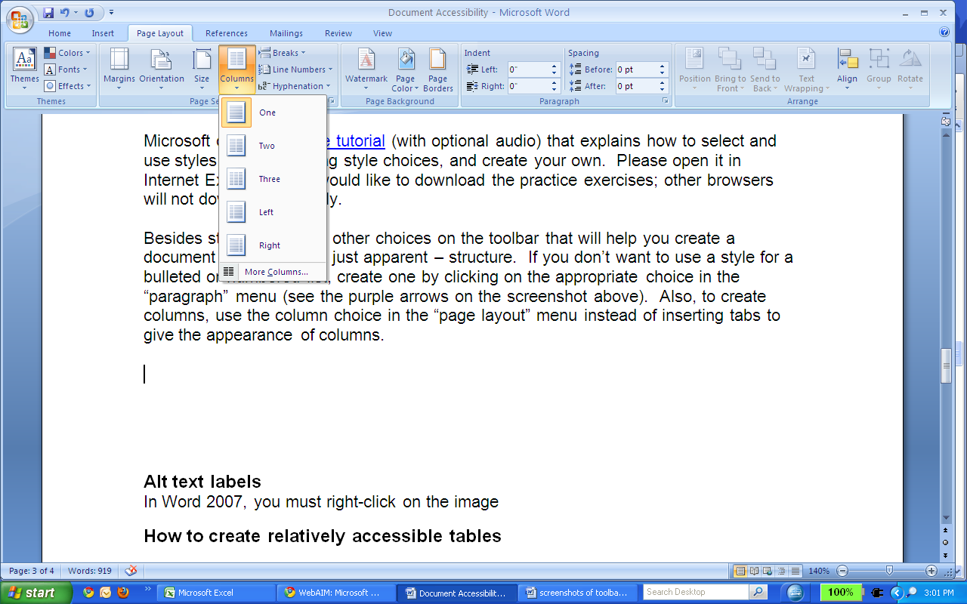

[Back to Contents](#_Contents)

## Alt text labels

A screen reader can only read text, not images or non-text graphics (e.g., WordArt in Word 2010 is rendered as text, but not in earlier versions; a screen reader could only read WordArt created using the 2010 software). Therefore, a reader who cannot see your document will only learn that there is an image there, not what the image is or what function it serves in the document. Alt text is the solution to this accessibility problem in most instances.

Alt text also makes web pages more accessible to anyone who is browsing on a weak internet connection or a small portable device like a phone. The alt text labels become visible while images are loading, or if they are turned off or otherwise unavailable.

There are three general categories of images you might include in a document:

1. Simple images, such as photos, screenshots, or cartoons that illustrate or communicate information;

2. Graphics, clip art, or other visual elements that serve a strictly decorative purpose, but do not convey information; and

3. More complicated images such as graphs, complex tables, or maps.

You will do something different with images in each of these categories.

#### Simple images

Photos and the like require brief explanatory alt text labels. To enter these using Word 2007, you must right-click on the image, and then select the “size” option (second from the bottom) in the pop-up menu.

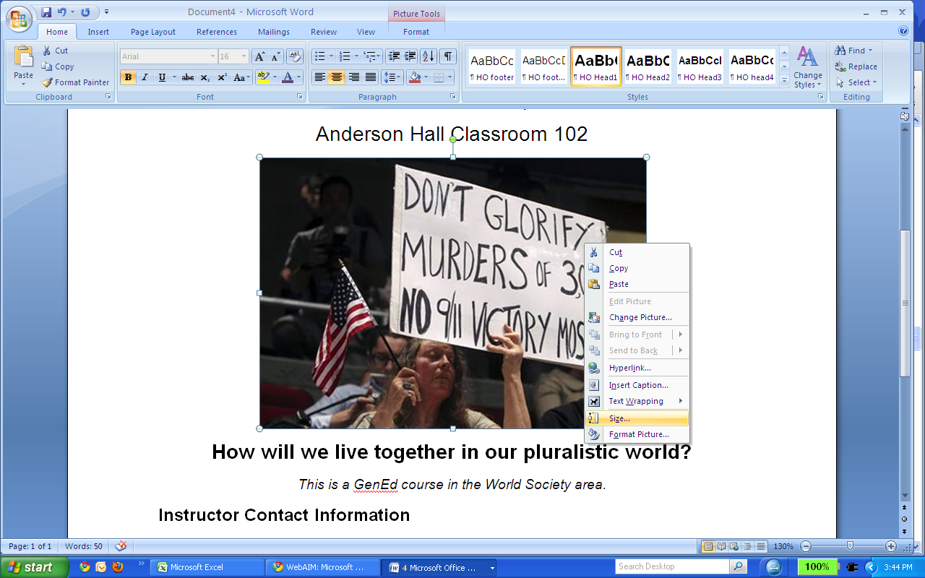

In the “size” window, click on the “alt text” tab. Enter a *short* description of the image; it should provide just enough information for the reader to understand why the image is there.

The alt text process is slightly different in Word 2000-03. When you right-click on the image, you will choose “format picture.” There will be a tab for alt text in the “format picture” window.

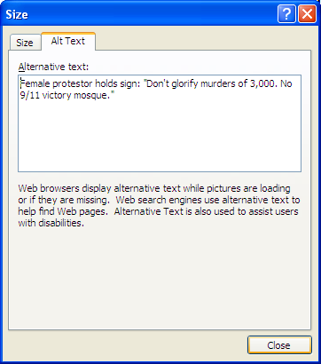

In the screenshot to the left, the author has provided the following description: “Female protestor holds sign: ‘Don’t glorify murders of 3,000. No 9/11 victory mosque.” This label makes a connection between the photo and the caption, “How will we live together in our pluralistic world?” Note that the label does not begin with “photo of”; that type of descriptor is superfluous.

#### Decorative images

By definition, decorative images do not convey information. Therefore, someone using screen-reading software would not need to bother with them, and is better off if the screen reader simply skips over them. To get this result, simply enter a space in the alt text box.

#### More complex images

When you are including a visual element that requires more extensive explanation than an alt text label can provide, you must do two things:

* Enter alt text as usual, indicating the basic nature and function of the graph, chart, map, etc.
* Provide a sufficiently detailed description of the relevant data or other content. You may include this in the surrounding text or create a separate document containing the description. Provide a link to that document in the caption, indicating that a text description is available. For instructions on these and other more technologically sophisticated methods of providing long descriptions, see the WebAIM article on [long descriptions](http://webaim.org/techniques/images/longdesc).

[Back to Contents](#_Contents)

## Data Tables

At the moment, there is no reliable way for a non-specialist to generate data tables that are completely accessible to a reader who is blind. However, simple tables (those with only one row of column and row headings) are sufficiently intelligible if you create them using the “table” option in Word. If the table does not fit on one page, select the “repeat header rows” option on the “table tools: layout” toolbar to make sure the column headings repeat on the next page. See the screenshot below, where that icon is highlighted and the headings are replicated on the second page.

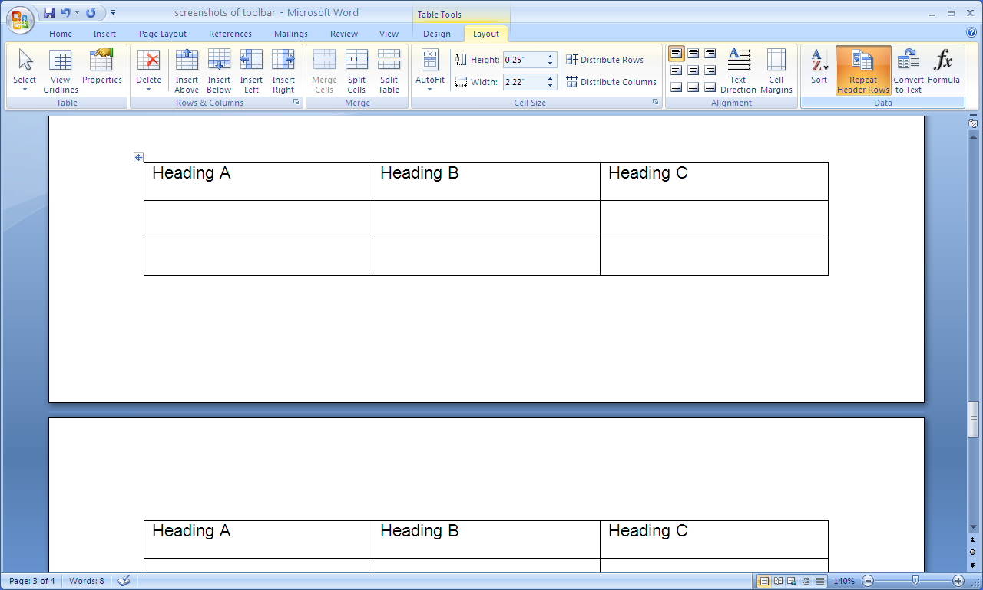

If you have a very large or complex table, consider reformatting the data into two simpler or smaller tables. All your students will probably appreciate this move if it makes the data easier to locate and understand.

Screen readers will read across the table from left to right, unless you insert code to change the read order. Therefore, orient the data table so that your students will be able to work with it most readily (given the purposes you have for the task) by reading across each row.

Be sure to include an [alt text label](#_Alt_text_labels_1) for every table. If the table has multiple heading rows or a great deal of data, provide a longer text description of the content. (See “[More complex images](#_More_complex_images)” above).

If you know how to work with HTML markup, you can create tables that a screen reader can render quite intelligibly. See the WebAIM article, “[Creating Accessible Tables](http://webaim.org/techniques/tables/data)” for detailed instructions.

[Back to Contents](#_Contents)

## Hyperlinks

The WebAIM article, “[Links and Hypertext](http://webaim.org/techniques/hypertext/),” gives a thorough explanation of accessibility issues related to hyperlinks. You will find brief highlights in what follows.

It is confusing and tedious for a student using a screen reader to listen to a long URL associated with a hyperlink. To avoid this, embed the URL in a hyperlink with a short descriptive label that informs the reader what the linked material is about. Do not use vague, content-less labels such as “click here,” “read more,” or “link.” In fact, you don’t even need to use those phrases at the beginning of a more informative link: “economic data” is better than “click here for economic data” because it is more concise.

Anytime you link to a file in a different format, alert the reader to the type of file the link will open. For example, “PowerPoint tutorial on Lexis/Nexis database” or “Class participation options (PDF).”

#### How to create a link to a URL

In Word 2007, use the “Insert” menu and choose “Hyperlink.” You will have a choice to link to an existing document, to a web page, to a place in the current document, to a new document you will create on the spot, or to an email address. In the screenshot below, the “existing file or web page” choice is highlighted, and the URL has been pasted (control + V) into the “Address” space. The last step is to click “OK,” and the link will appear in the document.

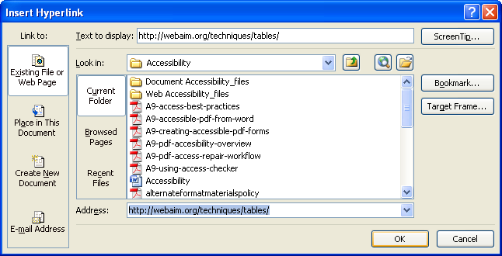

[Back to Contents](#_Contents)

# Online Resources

[WebAIM article](http://webaim.org/techniques/word/) on creating accessible Word documents:

* Provides instructions for Word 200-2003, Word 2007-2010, and Word for Mac.
* Covers four major accessibility issues related to Word documents: structuring your document using styles; providing alternative text for images; creating data tables; and embedding informative hyperlinks.

[WebAIM alternative text tutorial](http://webaim.org/techniques/alttext/).

Microsoft [tutorial](http://office.microsoft.com/en-us/word-help/format-your-document-with-styles-RZ010356279.aspx) in using styles in Word 2007.